Risk prediction models to manage Fusarium Head Blight epidemics in Canadian prairie cereal production
Taurai T. Matengu¹, Paul Bullock¹, Manasah S. Mkhabela¹, Francis Zvomuya¹, Maria A. Henriquez², Timi Ojo³, Réjean Picard⁴, Raul Avila⁵, Alireza Akhavan⁵ and Michael Harding⁶

¹Department of Soil Science, University of Manitoba, Winnipeg, MB, Canada; ²Morden Research and Development Centre, Agriculture and Agri-Food Canada, Morden, MB, Canada; ³Soil and Ag Weather Surveillance, Manitoba Agriculture and Resource Development, Winnipeg, MB, Canada; ⁴Ag-adaptation Specialist - Crops, Manitoba Agriculture and Resource Development, Morden, MB, Canada; ⁵Ministry of Agriculture, Government of Saskatchewan, Regina, SK, Canada; ⁶Plant and Bee Health Surveillance, Alberta Agriculture and Forestry, Brooks, AB, Canada

Introduction

Fusarium head blight (FHB), caused primarily by Fusarium graminearum in western Canada, is a significant threat to wheat and barley yield and quality, especially in warm and humid conditions (Tekauz et al., 2000). Producers mainly manage FHB through agronomic practices such as using resistant varieties and applying fungicides. Visual disease symptoms appear two to three weeks after flowering, posing a burden on producers who must decide whether to apply fungicides before knowing if or how much FHB infection will occur. Once symptoms appear, the damage has been done, and the application of fungicides is futile. Applying fungicides is costly and an unnecessary expense if applied when not needed, i.e., in years with low disease pressure. Considering the importance of fungicide application timing, growers require a risk advisory system to help them make informed management decisions. Several weather-based models have been developed to predict FHB levels in wheat (Moschini et al., 2001; Hooker et al., 2002; De Wolf et al., 2003; Rossi et al., 2003; Del Ponte et al., 2005; Shah et al., 2013). Existing weather-based models utilized in western Canada that were developed in the USA many years ago may not represent the current FHB chemotypes. Additionally, these models predict FHB epidemics with a field severity or FHB index (FHBi) greater than 10%, which is a disease severity level strongly correlated with FHB yield losses and generally linked to high levels of deoxynivalenol (DON) in harvested grain (De Wolf et al., 2003). However, there are instances where disease symptoms in the field do not accurately reflect the amount of Fusarium damaged kernels (FDK) and DON, and recent research demonstrates complex relationships between disease symptoms and DON accumulation in the field (Miedaner et al., 2016). Therefore, the objective of this study was to develop weather-based models that predict FHBi, FDK, and DON in winter wheat, spring wheat, barley, and durum using data collected in western Canada.

2. Materials and methods
2.1. Experimental site details, disease, and weather data collection
Small-plot trials at five sites per province (15 sites total) were conducted in Manitoba, Saskatchewan, and Alberta during the 2019 and 2020 growing seasons. The trials were established in areas where the fungal pathogen had been detected in the preceding two years and the soil already contained FHB inoculum. Sites were distributed geographically across western Canada to capture a range of weather conditions and FHB occurrences. FHB incidence and severity were assessed on the plots from 18 to 21 days after 50% anthesis (BBCH 65) and expressed as FHB index using the formula: FHBi = (FHB incidence x FHB severity)/100. One kilogram of grain from each plot was sent to a commercial laboratory for official grading, including FDK levels and DON analysis (Canadian Grain Commission, 2019). Portable weather stations were installed within 10 m of the plots to collect hourly growing-season weather data, including air temperature (°C), relative humidity (RH), precipitation (mm), solar radiation (W m⁻²), and wind speed (m s⁻¹). In total, 84 weather predictor variables were calculated using hourly weather data from 4, 7, 10, and 14 days before 50% anthesis plus the period between 3 days before and 3 days after 50% anthesis.
2.2. Data analysis
SAS was used for all analyses. The Kendall Tau-b correlation coefficient was calculated using the PROC CORR procedure, and model fitting and validation were performed using the PROC LOGISTIC procedure.
2.3. Model fitting and validation

Multiple logistic regression with a stepwise selection was used to develop models that predict the occurrence (=1) and non-occurrence (=0) of FHB epidemics using selected weather predictor variables. FHBi was binary coded as 0 or 1 using FHBi ≥5% as the epidemic threshold. Observations of FDK were binary coded to 0 or 1 using 0.2, 0.3, 0.8, and 1.5% FDK thresholds for barley, spring wheat, winter wheat, and durum, respectively. These cut-off values reflect the maximum level permitted in the number one grade for each crop type under Canadian regulations and serve as a justification for the application of fungicides to avoid revenue loss due to downgrading (Canadian Grain Commission, 2019). A DON threshold of 1 ppm was used to differentiate epidemic from non-epidemic cases, and this value corresponds to a value that results in wheat being downgraded during marketing, as established by the Canadian Food Inspection Agency (CFIA, 2017). The models were selected based on the receiver operating characteristic (ROC) curve metrics of sensitivity (percentage of correctly classified epidemic cases) and specificity (percentage of correctly classified non-epidemic cases), accuracy (ability to correctly classify both epidemic and non-epidemic cases), and the Hosmer-Lemeshow goodness of fit test (Hosmer et al., 2013). Validation of the models was conducted using an independent dataset collected from producer fields during the same two growing seasons.

3. Results and Discussion
3.1. Disease status
Mean FHBi, FDK, and DON levels ranged from 2.9 to 11.9%, 0.03 to 2.98%, and 0.04 to 2.83 ppm, respectively, across crop type and FHB resistance ratings (Figure 1). The FDK and DON levels were lower in the moderately resistant varieties compared to the susceptible varieties. Durum had the highest disease levels while barley had the lowest levels. The occurrence of FHBi, FDK, and DON reflects weather conditions that occurred at the plot sites during the 2019 and 2020 growing seasons. Warm, dry weather was most likely unfavorable for FHB epidemics at most sites during the two growing seasons.

3.2. Variable selection
Eighteen variables were found to be independently or jointly associated with FHB epidemics across crop types and crop damage indicators through correlation analysis and stepwise logistic regression (Table 1). Compared to rainfall variables, RH was a more frequently used moisture variable in the models.

3.3. Logistic regression models

Initially, 5 FHBi models for each crop type; 6 and 7 FDK models for Spring wheat and durum, respectively; and 9 DON models for durum were identified with > 70% prediction accuracy (data not shown). However, some of these models had low sensitivity, while others had numerous predictor variables (complex), necessitating the application of the principle of parsimony. The list was narrowed to two models, those with high sensitivity, specificity, accuracy, and best fit for each crop type and crop damage indicator for further evaluation and validation (Table 2). Two winter wheat models (models WWFHB1 and WWFHB2) correctly classified 73 and 97% of the FHB epidemics, respectively (sensitivity), but correctly classified 76 and 61% of the FHB non-epidemics (Specificity). Spring wheat models (SWFHB1 and SWFHB2) had an equal prediction accuracy of 76%. The accuracy of the FHBi models for durum and barley ranged from 76 to 81%. The discrepancies in FHBi accuracy could be attributed to various factors, including late disease infection and differences in Fusarium species infecting the crop. This indicates that FHBi models may not accurately predict FDK and DON levels, and thus FDK and DON prediction models were developed.

Spring wheat and durum FDK models predicted epidemic cases more accurately than non-epidemic cases using RH as the sole predictor variable (Table 2). Weather conditions 10 days before mid-anthesis provided a more accurate FDK prediction than conditions at 4, 7, or 14 days before mid-anthesis. Shorter time periods may miss information about pathogen-environment interactions, whereas more extended periods may include unnecessary information (Shah et al., 2013; Giroux et al., 2016). The accuracy of the two Durum DON models was equal (78 and 79% for DONDU1 and DONDU2, respectively). However, these models predict more non-epidemic cases than epidemic cases. The FHBi, FDK, and DON models were validated using data from 199 producer fields collected over the same two growing seasons. The models exhibited accuracy ranges of 80 to 100 for FHBi, 54 to 89 for FDK, and 75 to 82% for DON (Table 2). However, sensitivity was infinite or low because there were no or few epidemic cases to predict.

4. Conclusion
Models for predicting FHBi, FDK, and DON had high prediction accuracy in both development and validation datasets. These models will be used to develop an online tool for assessing the risk of FHB and guiding the application of fungicides in the Canadian prairies. This risk assessment tool will allow producers to optimize fungicide application by avoiding unnecessary fungicide application and losses due to epidemics. The data used in this study were limited to two growing seasons and may not reflect all possible disease-weather conditions that could favor FHB epidemics. Therefore, more data from the 2021 growing season will be added to refine and validate these models.

Acknowledgment

This research was funded under the Integrated Crop Agronomy Cluster by Western Grain Research Foundation, Agriculture and Agri-Food Canada, Manitoba Crop Alliance, Saskatchewan Wheat Development Commission, Alberta Wheat Commission, Brewing and Malting Barley Research Institute, Canadian Agricultural Partnership, and Prairie Oat Growers Association. Special thanks to the producer collaborators, technicians, summer students, and colleagues who took part in this project.

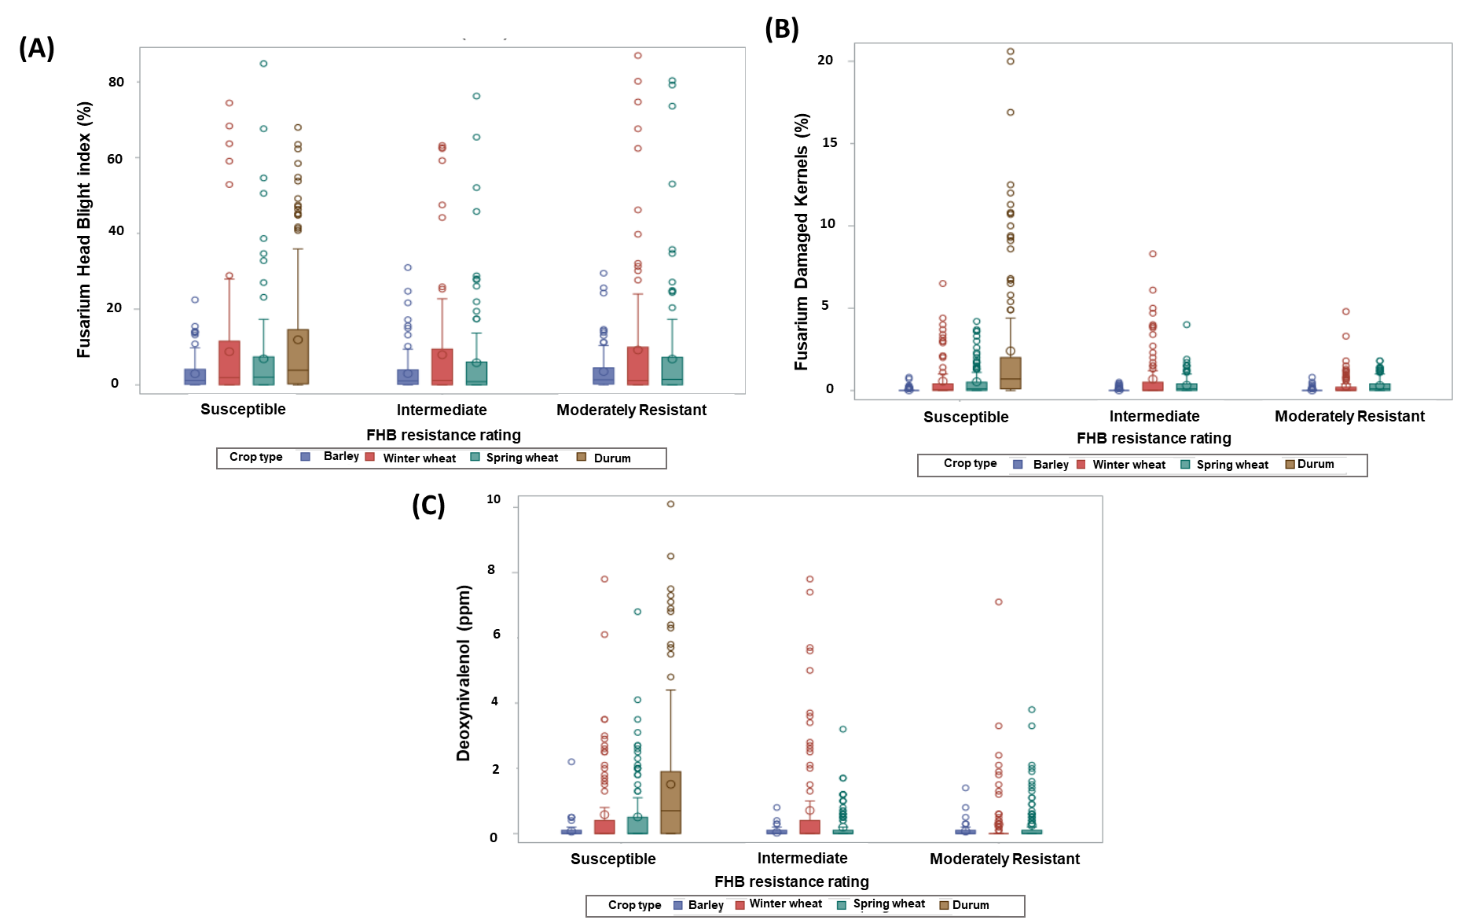

Figure 1. Fusarium head blight index (A) Fusarium damaged kernels (B) and Deoxynivalenol (C) occurrence in the 2019 and 2020 growing season in Manitoba, Saskatchewan, and Alberta.

Table 1. Description of selected weather predator variables
Variable | Variable Description | Days Prior to Mid-Anthesis
RH4MA | Mean daily relative humidity (%) | 4
RH804MA | Duration (h) RH ≥ 80 % | 4
T252804MA | Duration (h) air temperature 25 ≤ T ≤ 28ºC | 4
Tmin4MA | Mean daily minimum temperature (%) | 4
TRH804MA | Duration (h) air temperature 15 ≤ T ≤ 30ºC, and RH ≥ 80 % | 4
TRH904MA | Duration (h) air temperature 15 ≤ T ≤ 30ºC, and RH ≥ 90 % | 4
R4MA | Mean daily rainfall (mm) | 4
RH7MA | Mean daily relative humidity (%) | 7
RH807MA | Duration (h) RH ≥ 80 % | 7
T7MA | Mean daily temperature (º C) | 7
Tmin7MA | Mean daily minimum temperature (%) | 7
RH10MA | Mean daily relative humidity (%) | 10
RH8010MA | Duration (h) RH ≥ 80 % | 10
TRH8010MA | Duration (h) air temperature 15 ≤ T ≤ 30ºC, and RH ≥ 80 % | 10
RH8014MA | Duration (h) RH ≥ 80 % | 14
T252814MA | Duration (h) air temperature 25 ≤ T ≤ 28ºC | 14
R14MA | Mean daily rainfall (mm) | 14
RHmax14MA | Mean daily maximum relative humidity (%) | 14

Table 2. Selected Fusarium head bight index, Fusarium damaged Kernel and Deoxynivalenol models for spring wheat, winter wheat, barley and durum.
Crop Type | Crop Damage Indicator | Model equation (p =1/1 +exp^{- (a + bX +…)})^{v} | Optimum predicted threshold^{w} | Sensitivity^{x} | Specificity^{y} | Accuracy^{z}
Winter Wheat | WWFHB1 | -0.1188+0.0185RH807MA+0.7846Tmin7MA-0.6239T7MA | 0.37 | 73.2 | 75.9 | 75
 | WWFHB2 | -5.1095+0.0312RH8014MA | 0.17 | 96.9 | 61.3 | 79
Spring Wheat | SWFHB1 | -6.1086+0.1267RH804MA+0.2461T252804MA-0.1414TRH904MA | 0.25 | 82.4 | 68.9 | 76
 | SWFHB2 | -34.5786+0.3513RHmax14MA+0.0435T252814MA | 0.39 | 79.8 | 72.7 | 76
Barley | BAFHB1 | -6.4679+0.1560RH804MA+0.2981T252804MA-0.1137TRH804MA | 0.42 | 74 | 86.6 | 80
 | BAFHB2 | -37.7241+0.2146R14MA+0.0495T252814MA | 0.27 | 89.9 | 63.4 | 77
Durum | DUFHB1 | -2.0665+0.0326TRH8010MA | 0.39 | 91.5 | 70.2 | 81
 | DUFHB2 | -8.3268+0.5906Tmin4MA+0.2714R4MA | 0.58 | 70.2 | 80.7 | 76
Spring Wheat | SWFDK1 | -31.6372+ 0.40037RH10MA | 0.37 | 86.4 | 83.4 | 85
 | SWFDK2 | -25.27+0.3167RH7MA | 0.32 | 83.6 | 72.5 | 78
Durum | DUFDK1 | -11.9932+0.0847RH8010MA | 0.29 | 83.3 | 74.2 | 79
 | DUFDK2 | -17.9341+0.2185RH4MA | 0.28 | 80 | 73 | 77
Durum | DUDON1 | -20.7748+0.2646RH10MA | 0.57 | 71.7 | 84.9 | 78
 | DUDON2 | -24.1039+0.3114RH14MA | 0.51 | 69.6 | 89 | 79
^{v}Logistic regression models were developed using 2019 and 2020 data collected in Manitoba, Saskatchewan, and Alberta. Variables are defined in Table 1. P= probability of an epidemic event (1), a and b are the model coefficients, and X is the predictor variable(s).
^{w}The optimal predicted probability of an epidemic case, as determined by Youden index max (where sensitivity and specificity for the full range of p values, are high).
^{x} Sensitivity is the percentage of correctly classified epidemics cases (epidemic = FHBi ≥ 5%).
^{y} Specificity is the percentage of correctly classified non-epidemic cases.
^{z} Accuracy is the percentage of correctly classified cases of epidemic and non-epidemic (true positive proportion + true negative proposition /2
References

Canadian Grain Commission. 2019. Official grain grading guide. https://www.grainscanada.gc.ca/en/grain-quality/official-grain-grading-guide/04-wheat/grading-factors.html (accessed 24 June 2020). (accessed 24 June 2020).
CFIA. 2017. RG-8 Regulatory Guidance: Contaminants in feed (formerly RG-1, Chapter 7) - Animal health - Canadian Food Inspection Agency (CFIA). https://www.inspection.gc.ca/animal-health/livestock-feeds/regulatory-guidance/rg-8/eng/1347383943203/1347384015909?chap=0 (accessed 24 June 2020).

De Wolf, E.D., L.V. Madden, and P.E. Lipps. 2003. Risk assessment models for wheat Fusarium head blight epidemics based on within-season weather data. Phytopathology® 93: 428–435. doi: 10.1094/PHYTO.2003.93.4.428.
Del Ponte, E.M., J.M.C. Fernandes, and W. Pavan. 2005. A risk infection simulation model for fusarium head blight of wheat. Fitopatol. Bras. 30: 634–642. doi: 10.1590/S0100-41582005000600011.
Giroux, M.-E., G. Bourgeois, Y. Dion, S. Rioux, D. Pageau, et al. 2016. Evaluation of forecasting models for Fusarium Head Blight of wheat under growing conditions of Quebec, Canada. Plant Dis. 100: 1192–1201. doi: 10.1094/PDIS-04-15-0404-RE.
Hooker, D.C., A.W. Schaafsma, and L. Tamburic-Ilincic. 2002. Using weather variables pre- and post-heading to predict deoxynivalenol content in winter wheat. Plant Dis. 86: 611–619. doi: 10.1094/PDIS.2002.86.6.611.
Hosmer, D.W., S. Lemeshow, and R.X. Sturdivant. 2013. Applied logistic regression. Third edition. Wiley, Hoboken, New Jersey.
Miedaner, T., R. Kalih, M.S. Großmann, and H.P. Maurer. 2016. Correlation between Fusarium head blight severity and DON content in triticale as revealed by phenotypic and molecular data (H. Bürstmayr, editor). Plant Breed. 135: 31–37. doi: 10.1111/pbr.12327.
Moschini, R.C., R. Pioli, M. Carmona, and O. Sacchi. 2001. Empirical predictions of wheat Head Blight in the Northern Argentinean Pampas Region. Crop Sci. 41: 1541–1545. doi: 10.2135/cropsci2001.4151541x.
Rossi, V., S. Giosuè, E. Pattori, F. Spanna, and A. Del Vecchio. 2003. A model estimating the risk of Fusarium head blight on wheat. EPPO Bull. 33: 421–425. doi: 10.1111/j.1365-2338.2003.00667.x.
Shah, D.A., J.E. Molineros, P.A. Paul, K.T. Willyerd, L.V. Madden, et al. 2013. Predicting Fusarium Head Blight epidemics with weather-driven pre- and post-anthesis logistic regression models. Phytopathology® 103: 906–919. doi: 10.1094/PHYTO-11-12-0304-R.
Tekauz, A., B. McCallum, and J. Gilbert. 2000. Review: Fusarium head blight of barley in western Canada. Can. J. Plant Pathol. 22: 9–16. doi: 10.1080/07060660009501156.

